Introduction

Welcome to the future of salon management and customer convenience with our Online Salon Booking System!

In today's fast-paced world, where time is of the essence, we are thrilled to introduce a seamless and innovative solution that transforms the way you book and manage salon appointments. Our Online Salon Booking System brings the power of technology to your fingertips, allowing you to effortlessly schedule appointments, select services, and connect with your favorite salons from the comfort of your own device.

Gone are the days of waiting on hold, coordinating busy schedules, and experiencing last-minute appointment changes. With our user-friendly platform, you can now take control of your beauty and wellness routines like never before.

PROJECT OVERVIEW
The Salon Booking System is a web-based application designed to help salon owners and staff manage their appointments, customers, and services. The system will provide an easy-to-use interface for customers to book appointments online and for salon staff to manage these appointments, track customer information, and manage salon services

Technologies Used:
Hardware Interfaces
Minimum Hardware requirement
- Processor: i3 or i5
- RAM:4 GB or Higher
- Monitor
- Mouse
- Hard disk: 80 GB

Software Interfaces
- Minimum Software requirement
- Java (Spring Boot, Hibernate)
- Apache Tomcat Server

All these types of software automatic configure inside operating system after installation it having Java, MYSQL, Apache and operating system base configuration file, it doesn’t need to configure manually.

SYSTEM ARCHITECTRE:
High-Level System Architecture
The architecture of the salon booking system can be divided into several layers, each responsible for specific tasks and functionalities. These layers include:

Presentation Layer:

This layer handles user interactions and provides the user interface.
It can be implemented using a frontend framework like Angular, React, or Vue.js.
The presentation layer communicates with the backend through RESTful APIs.
Application Layer:

This layer contains the business logic and acts as an intermediary between the presentation and data layers.
It's implemented using Spring Boot.
Key components in this layer include controllers, service classes, and DTOs (Data Transfer Objects).
Persistence Layer:

This layer is responsible for data storage and retrieval.
It uses Hibernate ORM for object-relational mapping to interact with the database.
The database could be MySQL, PostgreSQL, or another RDBMS.
Security Layer:

Handles user authentication and authorization.
Utilizes Spring Security to secure the application.
Defines access control rules and authentication mechanisms.
Integration Layer (Optional):

If the application needs to integrate with external services or payment gateways, this layer facilitates those integrations.
For example, integrating with a payment gateway for online payments.
Infrastructure Layer:

Manages system-level concerns such as logging, caching, and email sending.
Uses Spring Boot's built-in features and third-party libraries for these purposes.
External Services and Data Sources:

The system may interact with external services for tasks like sending emails or SMS notifications.
Data from external sources, such as geolocation services for finding nearby salons, can be incorporated.
Data Flow
The data flow in the salon booking system typically follows these steps:

User Interaction:

Customers interact with the frontend to browse services, schedule appointments, and manage their profiles.
Salon staff use the frontend to manage appointments, services, and customer data.
Frontend-Backend Communication:

The presentation layer communicates with the backend through RESTful API requests.
The API endpoints are defined in the application layer.
Business Logic:

In the application layer, controllers receive incoming requests, validate input, and invoke service classes to perform business logic.
Service classes interact with the persistence layer to fetch or modify data in the database.
DTOs may be used to transfer data between layers.
Database Interaction:

The persistence layer uses Hibernate to perform CRUD (Create, Read, Update, Delete) operations on the database.
The database stores information about customers, appointments, staff, services, and more.
Authentication and Authorization:

The security layer ensures that users are authenticated and authorized to perform specific actions.
Spring Security handles user sessions, authentication, and access control.
External Services Integration (If applicable):

If the system integrates with external services or data sources, the integration layer manages these interactions.
Infrastructure Services:

Infrastructure services such as logging, caching, and email sending are managed by the infrastructure layer.

Development Process:

Requirements gathering and analysis:

There are Two main users of this application one is the Admin, the admin here can be the administrator, the other is the User.
1) Admin (Administrator)
- Admin Can log in/log out of the system.
- Admin can Update/Delete/Search Users.
- Admin can Add/Update/Delete/View Service.
- Admin can Add/Update/Delete/Search/View Products.
- Can maintain Cart history & databases.
- Can maintain Payment history & databases.
- Can maintain Order history & databases.
- Can change password.
- Can manage “My Profiles”.

2) User
- Can log in/log out of the system.
- Users can manage their accounts.
- Can book/cancel appointements..
- Can make payments online.
- Can view Payment statements.
- Can maintain Order history & databases.
- Can change password.
- Can manage “My Profiles”.

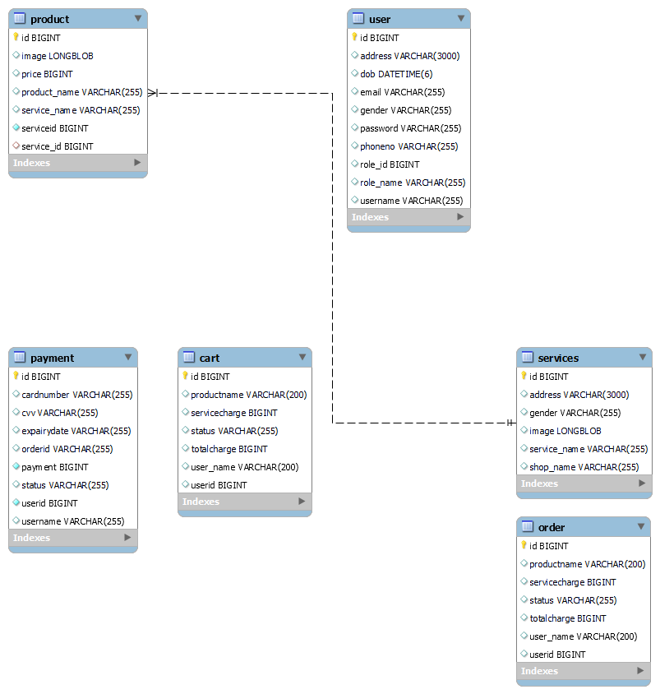
DATABASE DESIGN:

SYSTEM DESIGN :

User Interaction:

Customers interact with the frontend to browse services, schedule appointments, and manage their profiles.
Salon staff use the frontend to manage appointments, services, and customer data.
Frontend-Backend Communication:

The presentation layer communicates with the backend through RESTful API requests.
API endpoints are defined in the application layer.
Business Logic:

In the application layer, controllers receive incoming requests, validate input, and invoke service classes to perform business logic.
Service classes interact with the persistence layer to fetch or modify data in the database.
DTOs may be used to transfer data between layers.
Database Interaction:

The persistence layer uses Hibernate to perform CRUD (Create, Read, Update, Delete) operations on the database.
The database stores information about customers, appointments, staff, services, and more.
Authentication and Authorization:

The security layer ensures that users are authenticated and authorized to perform specific actions.
Spring Security handles user sessions, authentication, and access control.
External Services Integration (If applicable):

If the system integrates with external services or data sources, the integration layer manages these interactions.
Infrastructure Services:

Infrastructure services such as logging, caching, and email sending are managed by the infrastructure layer.
Deployment
The application can be deployed on a cloud platform (e.g., AWS, Azure, Heroku) or on a dedicated server. Consider using containerization (Docker) and orchestration (Kubernetes) for scalability and manageability.

In summary, the salon booking system's system design should be well-organized with clear separation of concerns, secure user authentication and authorization, and efficient data handling using Hibernate ORM. This architecture provides a scalable and maintainable foundation for building a robust salon booking application.

DATAFLOW DIAGRAM:
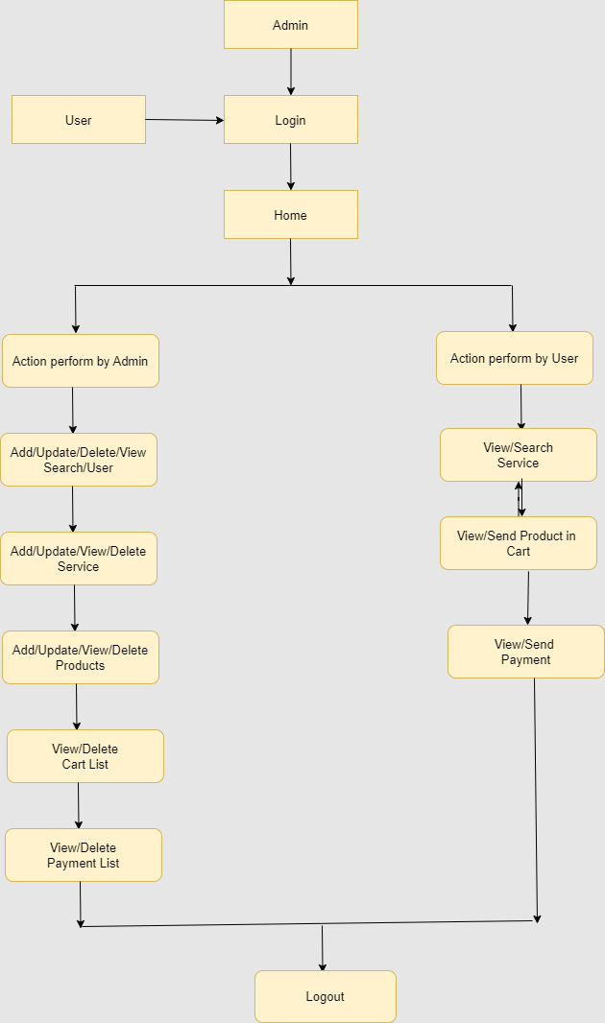

DEVELOPMENT:
Developing a salon booking project using Spring Boot and Hibernate involves several steps. Here, I'll provide you with a high-level overview of the development process. Please note that this is a simplified guide, and you may need to adapt it to your specific project requirements.

1. Set Up Your Development Environment
Before you begin, make sure you have the necessary tools and environment set up:

Install Java Development Kit (JDK)
Install an Integrated Development Environment (IDE) like IntelliJ IDEA or Eclipse
Set up a database server (e.g., MySQL, PostgreSQL)
Install Maven or Gradle for dependency management
2. Create a Spring Boot Project
Use Spring Initializr to create a new Spring Boot project. Choose the required dependencies, including Spring Web, Spring Data JPA, and any other relevant dependencies. Generate the project and import it into your IDE.

TESTING
Software Testing
Software testing is a process of verifying and validating that a software application or program.

Meets the business and technical requirements that guided its design and development, and Works as expected.

Software testing also identifies important defects, flaws, or errors in the application code that must be fixed. The modifier “important” in the previous sentence is, well, important because defects must be categorized by severity.

During test planning we decide what an important defect is by reviewing the requirements and design documents with an eye towards answering the question “Important to whom?” Generally speaking, an important defect is one that from the customer’s perspective affects the usability or functionality of the application.

The quality assurance aspect of software development documenting the degree to which the developers followed corporate standard processes or best practices is not addressed in this paper because assuring quality is not a responsibility of the testing team.

The testing team cannot improve quality they can only measure it, although it can be argued that doing things like designing tests before coding begins will improve quality because the coders can then use that information while thinking about their designs and during coding and debugging.

Software testing has three main purposes: verification, validation, and defect finding.

The verification process confirms that the software meets its technical specifications. A “specification” is a description of a function in terms of a measurable output value given a specific input value under specific preconditions.
A simple specification may be along the line of “a SQL query retrieving data for a single account against the multi-month account-summary table must return these eight fields <list> ordered by month within 3 seconds of submission.”

The validation process confirms that the software meets the business requirements. A simple example of a business requirement is “After choosing a branch office name, information about the branch’s customer account managers will appear in a new window. The window will present manager identification and summary information about each manager’s customer base: <list of data elements>.”

Other requirements provide details on how the data will be summarized, formatted and displayed.

A defect is a variance between the expected and actual result. The defect’s ultimate source may be traced to a fault introduced in the specification, design, or development (coding) phases.

Testing methods
Software testing methods are traditionally divided into black box testing and white box testing. These two approaches are used to describe the point of view that a test engineer takes when designing test cases.

Black box testing
Black box testing treats the software as a "black box"—without any knowledge of internal implementation. Black box testing methods include: equivalence partitioning, boundary value analysis, all-pairs testing, fuzz testing, model-based testing, traceability matrix, exploratory testing and specification-based testing.

Specification-based testing: Specification-based testing aims to test the functionality of software according to the applicable requirements. Thus, the tester inputs data into, and only sees the output from, the test object. This level of testing usually requires thorough test cases to be provided to the tester, who then can simply verify that for a given input, the output value (or behavior), either "is" or "is not" the same as the expected value specified in the test case.
Specification-based testing is necessary, but it is insufficient to guard against certain risks.

Advantages and disadvantages:
The black box tester has no "bonds" with the code, and a tester's perception is very simple: a code must have bugs. Using the principle, "Ask and you shall receive," black box testers find bugs where programmers do not.

But, on the other hand, black box testing has been said to be "like a walk in a dark labyrinth without a flashlight," because the tester doesn't know how the software being tested was actually constructed.

As a result, there are situations when 1 a tester writes many test cases to check something that could have been tested by only one test case, and/or 2 some parts of the back-end are not tested at all.

Therefore, black box testing has the advantage of "an unaffiliated opinion," on the one hand, and the disadvantage of "blind exploring," on the other.

White box testing
White box testing is when the tester has access to the internal data structures and algorithms including the code that implement these.

Types of white box testing

API testing (application programming interface) - Testing of the application using Public and Private APIs

Code coverage - creating tests to satisfy some criteria of code coverage (e.g., the test designer can create tests to cause all statements in the program to be executed at least once)
Fault injection methods - improving the coverage of a test by introducing faults to test code paths

Mutation testing methods

Static testing White box testing includes all static testing

A sample testing life cycle

Although variations exist between organizations, there is a typical cycle for testing:

Requirements analysis: Testing should begin in the requirements phase of the software development life cycle. During the design phase, testers work with developers in determining what aspects of a design are testable and with what parameters those tests work.

Test planning: Test strategy, test plan, tested creation. Since many activities will be carried out during testing, a plan is needed.

Test development: Test procedures, test scenarios, test cases, test datasets, test scripts to use in testing software.

Test execution: Testers execute the software based on the plans and tests and report any errors found to the development team.

Test reporting: Once testing is completed, testers generate metrics and make final reports on their test effort and whether or not the software tested is ready for release.

Test result analysis: Or Defect Analysis, is done by the development team usually along with the client, in order to decide what defects should be treated, fixed, rejected (i.e. found software working properly) or deferred to be dealt with later.

Defect Retesting: Once a defect has been dealt with by the development team, it is retested by the testing team.

Regression testing: It is common to have a small test program built of a subset of tests, for each integration of new, modified, or fixed software, in order to ensure that the latest delivery has not ruined anything, and that the software product as a whole is still working correctly.

Test Closure: Once the test meets the exit criteria, the activities such as capturing the key outputs, lessons learned, results, logs, documents related to the project are archived and used as a reference for future projects.

DEPLOYMENT:

Deploying a salon booking project involves taking your developed application and making it accessible to users on a web server or cloud platform. Here's a general guide on how to deploy a Spring Boot project:

1. Prepare Your Application for Deployment
Before deploying your salon booking project, make sure it's ready for production. This includes:

Ensuring all features are thoroughly tested.
Optimizing your code for performance and scalability.
Handling any sensitive information securely (e.g., database credentials, API keys).
Configuring your application for a production environment (e.g., different database settings, debug logging disabled).
Building a production-ready JAR or WAR file.
2. Choose a Deployment Environment
Decide where you want to deploy your Spring Boot application. Common deployment options include:

Traditional Web Server: You can deploy your application on a web server like Apache Tomcat or Nginx. You'll need to package your Spring Boot application as a WAR file.

Cloud Platforms: Use cloud platforms like AWS, Azure, Google Cloud, or Heroku for scalable and easily managed deployments. Spring Boot is well-suited for cloud-native applications.

Docker Containers: Containerization with Docker allows you to package your application along with its dependencies into a single container. This container can then be deployed on various platforms.

Kubernetes: If you need to manage and orchestrate multiple containers in a distributed environment, consider using Kubernetes.

3. Configure Your Database and Environment
Ensure that your database server is set up and accessible from your deployment environment. Update your application's configuration to point to the production database, adjust connection pools, and manage database schema migration scripts if necessary.

Set environment-specific properties for your application, such as production database connection details, external service endpoints, and security settings. You can use environment variables or property files for this purpose.

4. Deploy Your Application
The deployment process depends on the chosen deployment environment:

Traditional Web Server: If deploying to a web server, you'll need to upload your WAR file to the server and configure the server to run your application.

Cloud Platforms: On cloud platforms like AWS, you can use services like Elastic Beanstalk, AWS Lambda, or AWS Fargate to deploy your Spring Boot application. Similar services are available on other cloud providers.

Docker Containers: Build a Docker image of your application and push it to a container registry (e.g., Docker Hub, AWS ECR). Then, use a container orchestration tool like Docker Compose or Kubernetes to run your containers.

Kubernetes: If using Kubernetes, create Kubernetes deployment and service resources to manage your Spring Boot application's pods and services.

5. Set Up Load Balancing and Scaling (if needed)
For high availability and scalability, consider using load balancers to distribute incoming traffic across multiple instances of your application. Cloud providers often offer load balancing services.

You can also set up auto-scaling policies to automatically adjust the number of application instances based on traffic demands.

6. Configure Security
Implement security best practices, including setting up firewalls, securing communication with HTTPS, and properly configuring access control. If your application handles sensitive user data, consider compliance with data protection regulations.

7. Monitor and Maintain
Implement monitoring and logging solutions (e.g., Prometheus, ELK Stack) to track application performance, detect issues, and gather insights into user behavior.

Regularly update and maintain your deployed application by applying patches, addressing vulnerabilities, and improving performance based on usage patterns.

8. Documentation and Backup
Ensure that you have clear documentation for maintaining the deployed application, including procedures for backups, disaster recovery, and scaling.

Remember that deployment is an ongoing process, and you'll need to continue monitoring, maintaining, and updating your salon booking project to keep it running smoothly and securely in a production environment.

Source Code

Database Configuration
#server port
server.port=9090

#prefix and suffix configration
spring.mvc.view.prefix=/WEB-INF/layouts/
spring.mvc.view.suffix=.jsp

#Database Configrations
spring.datasource.url=jdbc:mysql://localhost:3306/onlinesalonbooking
spring.datasource.driver-class-name=com.mysql.cj.jdbc.Driver
spring.datasource.username=root
spring.datasource.password=root
spring.jpa.database-platform = org.hibernate.dialect.MySQL8Dialect

spring.jpa.generate-ddl=true
spring.jpa.hibernate.ddl-auto = update
#context Path

server.servlet.context-path=/OnlineSalonBookingSystem
server.servlet.session.timeout=10m
server.servlet.session.cookie.max-age = 1000

Controller:

package online.salon.booking.system.controller;

import java.io.ByteArrayInputStream;
import java.io.IOException;
import java.io.InputStream;
import java.sql.Blob;
import java.util.List;

import javax.servlet.ServletException;
import javax.servlet.http.HttpServletRequest;
import javax.servlet.http.HttpServletResponse;
import javax.servlet.http.HttpSession;
import javax.validation.Valid;

import org.apache.commons.io.IOUtils;
import org.springframework.beans.factory.annotation.Autowired;
import org.springframework.data.repository.query.Param;
import org.springframework.stereotype.Controller;
import org.springframework.ui.Model;
import org.springframework.validation.BindingResult;
import org.springframework.web.bind.annotation.GetMapping;
import org.springframework.web.bind.annotation.ModelAttribute;
import org.springframework.web.bind.annotation.PathVariable;
import org.springframework.web.bind.annotation.PostMapping;
import org.springframework.web.bind.annotation.RequestMapping;
import org.springframework.web.bind.annotation.RequestMethod;
import org.springframework.web.bind.annotation.RequestParam;
import org.springframework.web.multipart.MultipartFile;

import online.salon.booking.system.dto.ProductDTO;
import online.salon.booking.system.dto.ServicesDTO;
import online.salon.booking.system.exception.DuplicateRecordException;
import online.salon.booking.system.form.ProductForm;
import online.salon.booking.system.form.ServicesForm;
import online.salon.booking.system.service.ProductInt;
import online.salon.booking.system.service.ServicesInt;

@Controller
public class ProductCtl extends BaseCtl{

@Autowired
public ServicesInt serviceint;

@Autowired
public ProductInt service;

@ModelAttribute
public void preload(Model model)
{
List<ServicesDTO> list = serviceint.list();
model.addAttribute("servicelist", list);
}

@GetMapping("/products")
public String ProductView(@ModelAttribute("form")ProductForm form,HttpSession session,Model model, HttpServletRequest request){
return "product";
}

@PostMapping("/addproduct")
public String submitProduct(@RequestParam("image")MultipartFile file, String operation,@Valid @ModelAttribute("form") ProductForm form,
BindingResult bindingResult,Model model,HttpServletRequest request) throws IOException
{

if (OP_RESET.equalsIgnoreCase(form.getOperation())) {
return "redirect:/product";
}

if (bindingResult.hasErrors()) {
return "product";
}

try {
if (OP_SAVE.equalsIgnoreCase(form.getOperation())) {
ProductDTO bean = (ProductDTO) populateDTO(form.getDTO(), request);
bean.setImage(form.getImage().getBytes());
long serviceid = bean.getServiceid();
ServicesDTO serviceDto = serviceint.FindByPk(serviceid);
String serviceName = serviceDto.getServiceName();
bean.setServiceName(serviceName);
if (bean.getId()>0) {
service.Update(bean);
model.addAttribute("success", "Product Data Updated");
}else {
service.add(bean);
model.addAttribute("success", "Product Added SuccessFully !!");
}
return "product";
}
} catch (DuplicateRecordException e) {
model.addAttribute("error", e.getMessage());
return "product";
}
return "product";
}

@RequestMapping(value = "/productsList", method = { RequestMethod.GET, RequestMethod.POST })
public String ProductList(@ModelAttribute("form") ProductForm form,
@RequestParam(required = false) String operation, Long id, HttpSession session, Model model) {

if (OP_RESET.equalsIgnoreCase(form.getOperation())) {
return "redirect:/productlist";
}

if (OP_SEARCH.equalsIgnoreCase(form.getOperation())) {
ProductDTO dto = (ProductDTO) form.getDTO();
List<ProductDTO> list = service.search(dto);
if (list.size() == 0) {
model.addAttribute("error", "Record not found");
}
model.addAttribute("list", list);
return "productlist";
}
List<ProductDTO> list = service.list();
if (list.size() == 0) {
model.addAttribute("error", "Record not found");
}
model.addAttribute("list", list);
return "productlist";
}

@GetMapping("/Service")
public String findByService(@ModelAttribute("form") ServicesForm form,
@RequestParam(required = false) String operation, Long serviceid, HttpSession session, Model model) {
ServicesDTO bean = serviceint.FindByPk(serviceid);
List<ProductDTO> list = service.productlist(bean.getId());
if (list.size() == 0) {
model.addAttribute("error", "Record not found");
}
model.addAttribute("list", list);
return "productlist";
}

@GetMapping("/deleteproduct")
public String Delete(@ModelAttribute("form") ProductForm form,
@RequestParam(required = false) String operation, Long id, HttpSession session, Model model) {
service.Delete(id);
model.addAttribute("success", "Deleted Successfully!!!");
List<ProductDTO> list = service.list();
model.addAttribute("list", list);
return "productlist";
}

@GetMapping("/Updateproduct")
public String findByPk(@ModelAttribute("form") ProductForm form,
@RequestParam(required = false) String operation, Long id, HttpSession session, Model model) {
ProductDTO bean = service.FindByPk(id);
form.populate(bean);
return "product";
}

@GetMapping("/productImage")
public void showImage(@Param("id") Long id, HttpServletResponse response, ProductDTO v)
throws ServletException, IOException {
v = service.FindByPk(id);
response.setContentType("image/jpeg, image/jpg, image/png, image/gif");
response.getOutputStream().write(v.getImage());
response.getOutputStream().close();
}

@GetMapping("/productImage/{id}")
public void getServicePhoto(HttpServletResponse response, @PathVariable("id") long id) throws Exception {

Blob blb=service.getImageById(id);

byte[] bytes = blb.getBytes(1, (int) blb.length());
InputStream inputStream = new ByteArrayInputStream(bytes);
IOUtils.copy(inputStream, response.getOutputStream());
}

}

DAO
package online.salon.booking.system.dao;

import java.sql.Blob;
import java.sql.SQLException;
import java.util.List;

import javax.persistence.EntityManager;
import javax.sql.rowset.serial.SerialBlob;
import javax.sql.rowset.serial.SerialException;

import org.hibernate.Criteria;
import org.hibernate.Session;
import org.hibernate.criterion.Restrictions;
import org.hibernate.query.Query;
import org.springframework.beans.factory.annotation.Autowired;
import org.springframework.stereotype.Repository;

import online.salon.booking.system.dto.CartDTO;
import online.salon.booking.system.dto.ProductDTO;
import online.salon.booking.system.exception.DuplicateRecordException;

@Repository
public class ProductDAOImpl implements ProductDAOInt{

@Autowired
public EntityManager entitymanger;

@Override
public long add(ProductDTO dto) throws DuplicateRecordException {
Session session = entitymanger.unwrap(Session.class);
long pk = (long) session.save(dto);
return pk;
}

@Override
public void Update(ProductDTO dto) throws DuplicateRecordException {
Session session = entitymanger.unwrap(Session.class);
session.merge(dto);

}

@Override
public void Delete(long id) {
Session session = (Session) entitymanger.unwrap(Session.class);
Query<ProductDTO> query = session.createQuery("delete from ProductDTO where id= "+id+"");
query.executeUpdate();

}

@Override
public List<ProductDTO> list() {
Session session = entitymanger.unwrap(Session.class);
Query<ProductDTO> query = session.createQuery("from ProductDTO", ProductDTO.class);
List<ProductDTO> list = query.getResultList();
return list;
}

@Override
public ProductDTO FindByPk(long pk) {
Session session = entitymanger.unwrap(Session.class);
ProductDTO dto = session.get(ProductDTO.class, pk);
return dto;
}

@Override
public ProductDTO FindByProductName(String productName) {
Session session = entitymanger.unwrap(Session.class);
Criteria criteria = session.createCriteria(ProductDTO.class);
criteria.add(Restrictions.eq("productName", productName));
ProductDTO dto = (ProductDTO) criteria.uniqueResult();
return dto;
}

@Override
public List<ProductDTO> search(ProductDTO dto) {
Session session = entitymanger.unwrap(Session.class);
Criteria criteria = session.createCriteria(ProductDTO.class);
if (dto != null) {
if (dto.getId()>0) {
criteria.add(Restrictions.eq("id", dto.getId()));
}
// if (dto.getServiceName() != null && dto.getServiceName().length()>0) {
// criteria.add(Restrictions.like("serviceName", dto.getServiceName() + "%"));
// }
if (dto.getProductName() != null && dto.getProductName().length()>0) {
criteria.add(Restrictions.like("productName", dto.getProductName() + "%"));
}
}
return criteria.list();
}

@Override
public Blob getImageById(long id) throws SerialException, SQLException {
Session session = entitymanger.unwrap(Session.class);
ProductDTO person = (ProductDTO) session.get(ProductDTO.class, id);
byte[] blob = person.getImage();
Blob bBlob = new SerialBlob(blob);
return bBlob;
}

@Override
public List<ProductDTO> productlist(long serviceid) {
System.out.println("in DAO");
Session session = entitymanger.unwrap(Session.class);
Query<ProductDTO> query = session.createQuery("from ProductDTO as b where b.serviceid = ?1 ", ProductDTO.class);
query.setParameter(1, serviceid);
List<ProductDTO> Rlist = query.getResultList();
return Rlist;
}

}

DTO/Entity
package online.salon.booking.system.dto;

import javax.persistence.Column;
import javax.persistence.Entity;
import javax.persistence.ManyToOne;
import javax.persistence.Table;

import lombok.Getter;
import lombok.Setter;

@Setter
@Getter
@Entity
@Table(name = "product")
public class ProductDTO extends BaseDTO{

@Column(name = "productName",length = 255)
private String productName;
@Column(name = "price",length = 255)
private long price;
@Column(name = "serviceName",length = 255)
private String serviceName;

@ManyToOne
private ServicesDTO service;

private long serviceid;

@Column(name = "image")
private byte[] image;

@Override
public String getKey() {
// TODO Auto-generated method stub
return null;
}

@Override
public String getValue() {
// TODO Auto-generated method stub
return null;
}

}

Services
package online.salon.booking.system.service;

import java.sql.Blob;
import java.sql.SQLException;
import java.util.List;

import javax.sql.rowset.serial.SerialException;
import javax.transaction.Transactional;

import org.springframework.beans.factory.annotation.Autowired;
import org.springframework.stereotype.Service;

import online.salon.booking.system.dao.ProductDAOInt;
import online.salon.booking.system.dto.CartDTO;
import online.salon.booking.system.dto.ProductDTO;
import online.salon.booking.system.exception.DuplicateRecordException;

@Service
public class ProductImpl implements ProductInt{

@Autowired
public ProductDAOInt dao;

@Override
public long add(ProductDTO dto) throws DuplicateRecordException {
ProductDTO exisBean = dao.FindByProductName(dto.getProductName());
if (exisBean != null){
throw new DuplicateRecordException("This Product is Already Exist");
}

long pk = dao.add(dto);
return pk;
}

@Override
@Transactional
public void Update(ProductDTO dto) throws DuplicateRecordException {
dao.Update(dto);
}

@Override
@Transactional
public void Delete(long id) {
dao.Delete(id);
}

@Override
public List<ProductDTO> list() {
List<ProductDTO> list = dao.list();
return list;
}

@Override
public ProductDTO FindByPk(long pk) {
ProductDTO dto = dao.FindByPk(pk);
return dto;
}

@Override
public ProductDTO FindByProductName(String productName) {
ProductDTO dto = dao.FindByProductName(productName);
return dto;
}

@Override
public List<ProductDTO> search(ProductDTO dto) {
List<ProductDTO> list = dao.search(dto);
return list;
}

@Override
@Transactional
public Blob getImageById(long id) throws SerialException, SQLException {
return dao.getImageById(id);
}

@Override
public List<ProductDTO> productlist(long serviceid) {
List<ProductDTO> list = dao.productlist(serviceid);
return list;
}

}

Screen Short

// Please add updated SS after configuration the project.
Conclusion :

In conclusion, the introduction of an Online Salon Booking System represents a significant step forward in transforming the way salons operate and engage with their clients. This innovative solution bridges the gap between convenience and personal care, offering clients the ability to book appointments with ease while allowing salon owners and staff to streamline their operations. The benefits of an Online Salon Booking System are manifold, benefiting both clients and businesses alike.With the security of ATM improving it has now become a safe mode of transaction. Hence it can be concluded that ATM is safe, fast, reliable, convenient, excisable and any time money machine.

